Ask your family if they will go for a walk with you. You could take your pet or your favourite toy too!  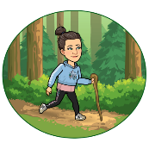 | Create a poster about how you show the school values.  Respect  Optimism  Care  Collaboration | Build a for or a comfy spot to read for 20 minutes.
Do something for a family member.  Eg. Tidy up, hang out the washing, sweep, cook a meal, wash the dishes. | Wellbeing Thursday | Go outside and look for shapes in the sky. How many different shapes could you see?
Play a board game with your family members | Act out a scene from your favourite book. | Find a song that puts you into the green zone.  