VANUATU CULTURAL
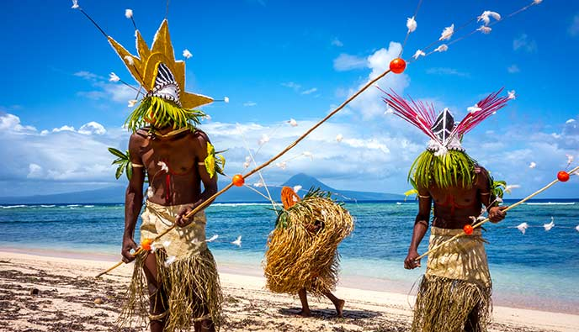
Vanuatu is recognised as one of the most culturally diverse countries in the world. Apart from the Ni-Vanuatu people, small communities of French, British, Australian, New Zealand, Vietnamese, Chinese and other Pacific Islanders make up the country’s population.
With no written language, storytelling and song and dance are of paramount importance to Vanuatu’s culture. Art, in its many forms, from body decorations and tattoos to elaborate masks, headwear and carvings are also a vital part of ritual celebrations and social life. Similar to Australian aboriginal stories and Maori legends of the past, Ni-Vanuatu culture is abundant in mythic legends.
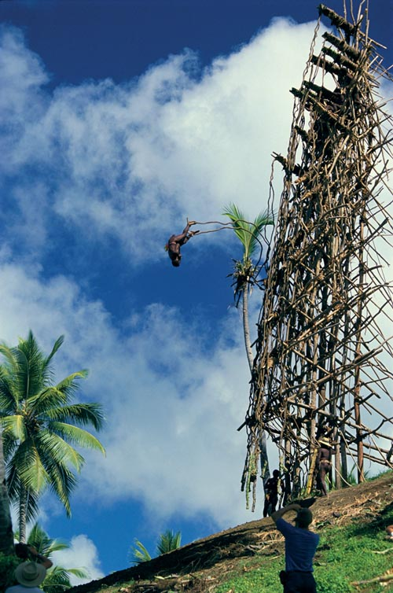
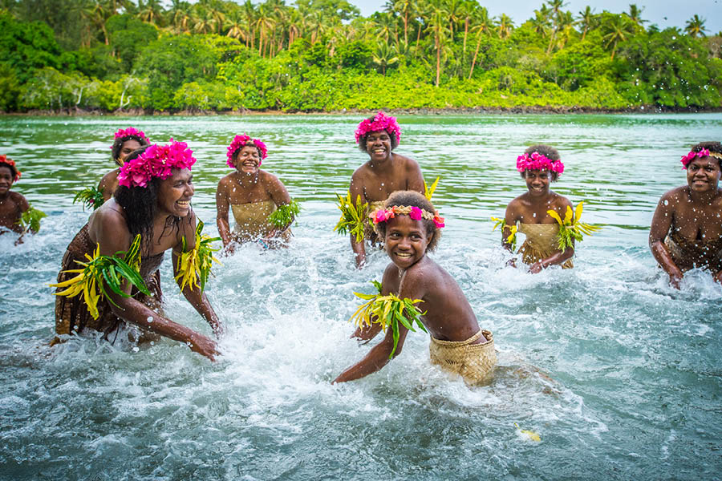

Vanuatu cultural festivals are unique and cannot be seen anywhere else in the world, these include:
- the death defying Pentecost Land Diving (nagol)
- the colourful and powerful Tanna Toka Dance which goes on for days
- the mystical Rom dance of Ambrym (island of magic and fire)
- the mesmerising Water Music performed by the women of the Gaua and Banks Islands.

Staple food on the islands includes mostly root crops such as yam, taro and manioc. Seasonal fruits like breadfruit are also important mainstays. Kava, a derivative of the pepper tree family, is a significant part of Vanuatu culture. Traditionally, it is cut and chewed into a pulp, then spat into a bowl. The mushy pulp is then squeezed into a liquid that’s drunk by both men and women as an evening soporific after a hard day’s work.
The country has 113 distinct languages and countless dialects, but a lingua franca evolved over the years with the arrival of European communities. Bislama, derived from the bech-der-mer (sea cucumber) traders, is essentially a phonetic form of English, with much simplified grammar. If listened to closely and spoken slowly, it can be understood by most English-speaking people.

