What Are The Major Natural Resources Of Vanuatu?

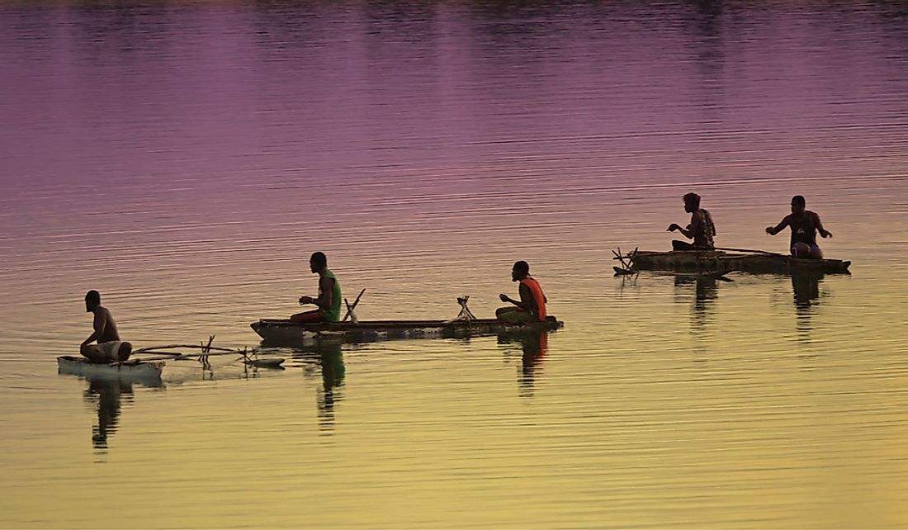F
(Fish are an important natural resource for the locals.)

Vanuatu is an island country situated south of the Pacific Ocean. It is approximately 1,090 miles east of Australia and 340 miles northeast of New Caledonia.
Most of the jobs on Vanuatu are in tourism, agriculture, livestock, and some foreign banking. Fishing is also an important activity but the fish are mainly sold and eaten in Vanuatu. It is not sold to other countries.
What is sold to other countries are beef, timber, copra, cocoa, and kava. Although it has few major natural resources, Vanuatu has managed to use what they do have, including fish, hardwood forests, and manganese. Selling these resources to foreign countries is an important way for the people of Vanuatu to make money.

Fish
The area around Vanuatu is rich in sea life and diversity of marine life. Fishing is an important economic activity for most of the people living in Vanuatu. The average fishing trips are approximately 3 per week. About 99% of the population works in fishing. This means different fishing villages are competing against each other for less and less fish.
The fisheries industry is managed by the Department of Fisheries and works and companies have to follow certain laws such as needing a fishing license from the department. The types of businesses involved in fishing are fishing charter boats and deep-bottom fish. Port Villa is an important port for these types of fishing, with almost 80% of the fishing businesses based there. The people of Vanuatu also work in aquaculture, which means fish farms. The majority of the farmers breed giant clams.

